Using the AdministratorDemo class to do test the default constructor, 6-parameter constructor, copy constructor, getters, equals method, readAdminInfo method, and toString method of the Administrator class. In this example, readAdminInfo has good input (default).  
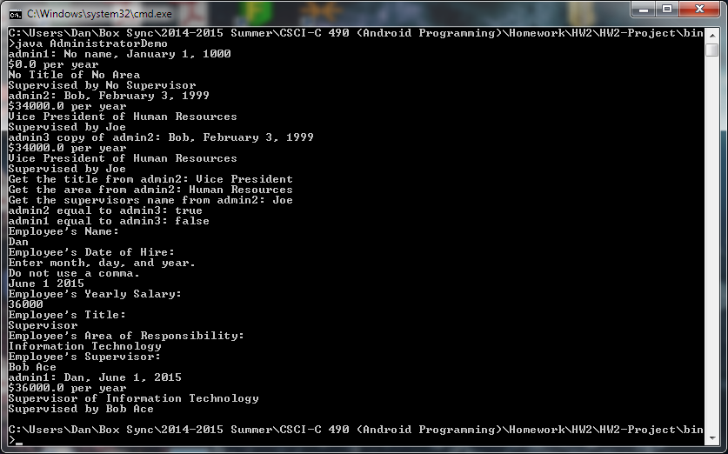

Showing that the readAdminInfo class won’t take an empty string for the Title, Area of Responsibility, and Supervisor’s Name.  
